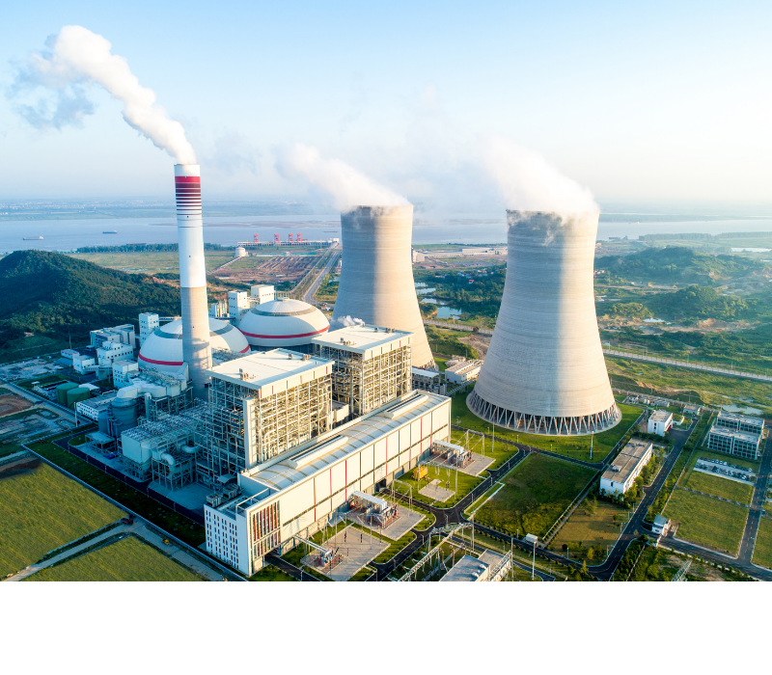

**What's The Filtration Application in Power Plant Boiler System?**

The three main equipment of the power plant are composed of boiler system, steam turbine system, and generator system. The state requires power plants to achieve zero emissions of pollutants, so that the emissions treatment of power plants should be higher, and at the same time, it also expands the market for filtration equipment.

In addition, the power plant water treatment system is also a complex treatment system. Power plant water is generally required to be recycled and reused, and water filtration treatment also requires many different filtration equipment.

Let's take a look at the following filtration application in boiler system of the power plant:

**Boiler System**

The boiler is one of the three main engines of the power plant and the heart of the thermal power plant. There are cycles through the boiler system: pulverized coal is burned to become coal ash and discharged; water is transformed into steam through the boiler and sent to the steam turbine; air is mixed into soot through the boiler.